**Batch:** B1 **Roll Number:** 1914078 **Name:** Devansh Shah

**Experiment Number:** 6

**Aim of the Experiment**: Write a program for implementation of solution of based a Murder Mystery using knowledge agent architecture.

**Program/ Steps:**

**STORY:**

Characters: Sparsh, Vidhi, Aayush, Devansh, Riya

Clue:

1. Devansh and Riya were not together. Devansh was in garden.

2. Sparsh and Vidhi are friends.

3. Sparsh and Riya are friends.

4. Sparsh wants to take revenge from Aayush.

5. Vidhi does not get along with Riya.

5. Devansh was with Aayush.

6. Aayush is neither killer nor victim.

6. Riya was not alone and was in club.

7. Sparsh and Vidhi were together and one among them is victim.

8. Sparsh was with one among Devansh and Riya.

9. Killer and victim was of same gender.

**CODE:**

# gender(devansh,male).

# gender(aayush,male).

# gender(sparsh,male).

# gender(riya,female).

# gender(vidhi,female).

# location(riya,club).

# location(devansh,garden).

# friends(sparsh,vidhi).

# friends(riya,sparsh).

# hates(sparsh,aayush).

# hates(riya,vidhi).

# together(devansh,aayush).

# together(sparsh,vidhi).

# together(sparsh,riya).

# holding(sparsh,rope).

# holding(riya,knife).

# holding(aayush,rope).

# holding(devansh,knife).

# killer(X) :- hates(X,Y),

# gender(X,B),gender(Y,B),

# (together(X,Y);together(Y,X);

# ( together(X,A),together(A,Y));

# ( together(A,X),together(A,Y))),

# X\=Y.

# victim(X) :- killer(Y),

# gender(X,B),

# gender(Y,B),

# (together(X,Y);together(Y,X);( together(X,A),together(A,Y));

# ( together(A,X),together(A,Y))),

# X\=Y.

# scene_location(X) :- (killer(Y);victim(Y)),

# (location(Y,X);location(X,Y)).

# object(X) :- killer(Y),

# holding(Y,X).

# Output:

# Killer:

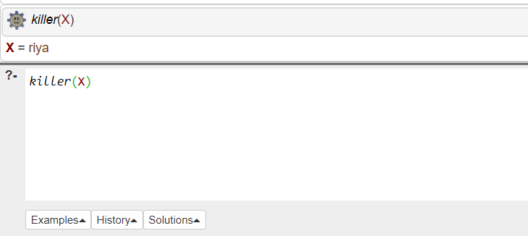

**Victim:**

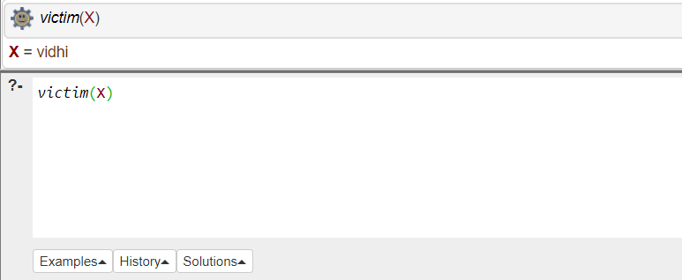

**Testing:**

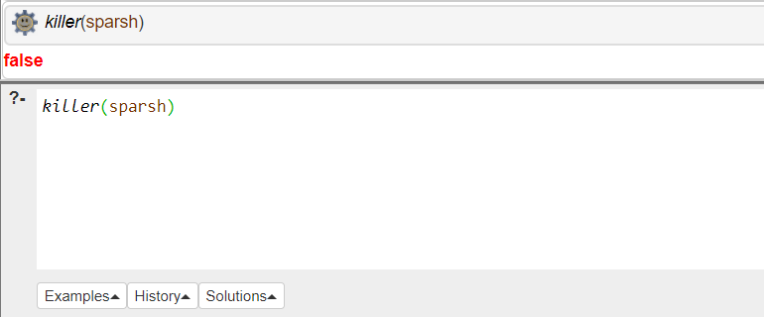

**Weapon:**

**Scene Location:**

**Outcomes:**

**CO3:** Ability to formally state the problem and develop the appropriate proof for given a logical deduction problem

**Conclusion:** We studied PROLOG and a murder mystery problem was created and was solved and tested in PROLOG.

**References:**

* Stuart Russell and Peter Norvig, Artificial Intelligence: A Modern Approach,

Second Edition, Pearson Publication

* Elaine Rich, Kevin Knight, Artificial Intelligence, Tata McGraw Hill, 1999.